**Raymond You and Elizabeth Cho**

**CS 3200 - Database Design**

**Project Final Report**

**Wardrobe App**

----------------------------------------------------------------------------------------------------------------------------

**1. Provide a README section for creating and running the project. I need complete specifications for building your project on my computer. Specify all libraries, software, etc. needed to run the application. Specify expected installation directories. If you use a specific technology for the project, the technology’s download page must be listed.**

-This is a wardrobe application built using Java and MySQL. The goal of this application was to build a better organization and logging system of all your clothes and outfits in your wardrobe so that you spend less time in the morning, frenzying over what clothes or outfits you should wear for that day.

-To run this application, you will need Java and MySQL Connector Java (5.1.46). First, unpackage the zip file and open the project folder in the IDE of your choice (IntelliJ was the IDE of choice for me here).

-Before running the program, you must run the SQL script to create and add the database to your MySQL database server.

-Next, you run the main method in Main.java and you are good to go!

-You can navigate through the application by following the instructions and commands as specified in the console. For example, you must first register an account in the database which is command 2.

-To finally exit the program, you must log out first then enter the command to exit the program.

**2. Provide the Technical Specifications (as defined in the progress report) for the project.**

Old technical specifications

-Python

-Flask

-MySQL

-HTML  
-CSS  
-JavaScript

-JQuery

New technical specifications

-Java

-MySQL

-GitHub (For version control)

**3. Provide the current UML for the project as well as the EER model for the submitted database schema (Reverse Engineer your final schema in the MySQL workbench). If you are submitting a Mongo database, please provide at least a UML diagram or some description of the schema.**

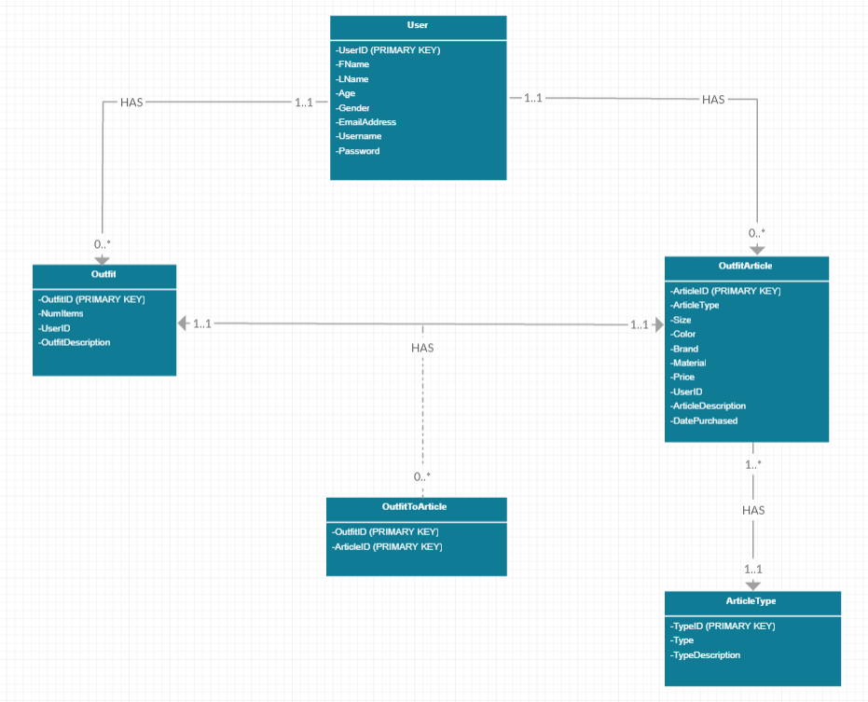

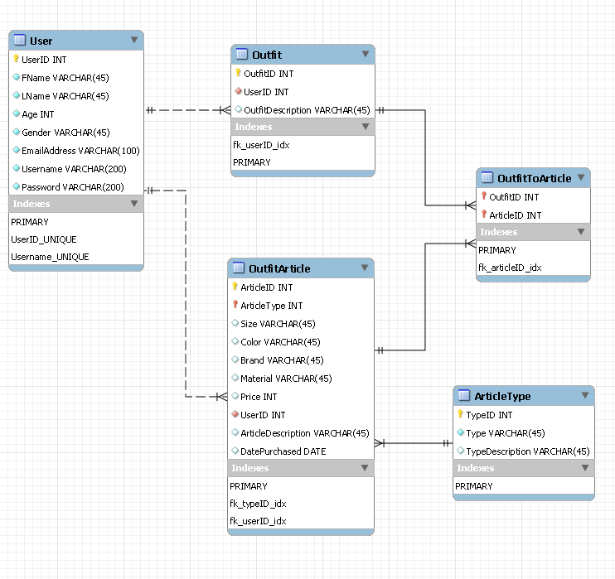

**4. Provide the final user flow of the system. List the commands or method the users performs to interact with the system.**

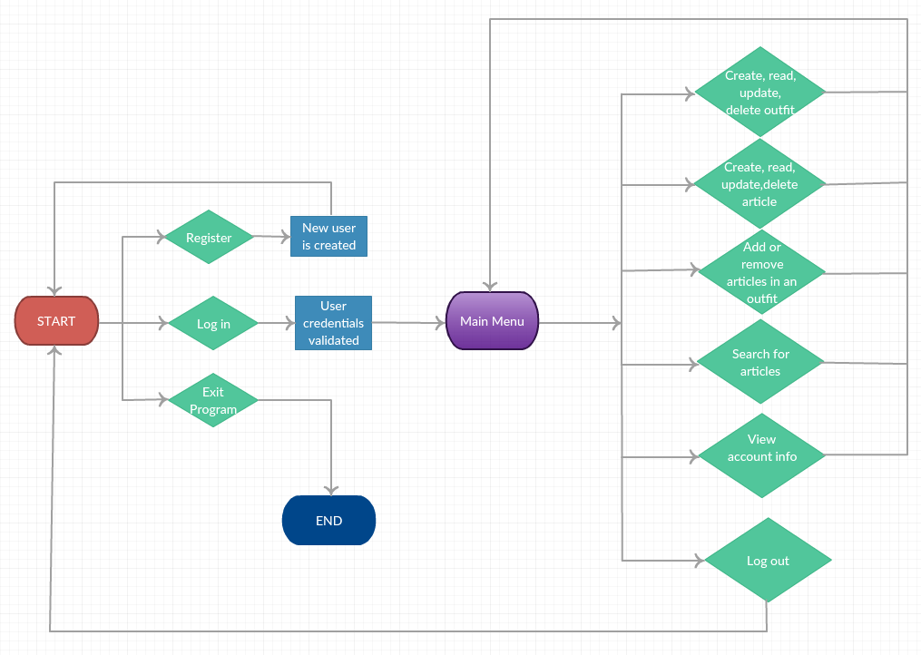

To navigate through the application, the user enters the number of the command he/she wishes to execute. The command list is outputted in the console by the program.

Before Main Menu

1. Login (Enter username and password)
2. Register (Enter name, age, gender, email address, username, password)
3. Exit Program

Main Menu (After logging in)

1. Create, read, update, or delete an outfit
2. Create, read, update, or delete an article
3. Add, remove, update, or view articles in an outfit
4. Search for articles
5. View Account info
6. Log Out

1. Create, read, update, or delete an outfit

1. Create an outfit (Enter description)
2. View an outfit
3. Update an outfit (Enter outfitID, new description)
4. Delete an outfit (Enter outfitID)
5. Go back to main menu

2. Create, read, update, or delete an article

1. Create an article (Enter type, size, color, brand, material, cost, description, date purchased)
2. View an article
3. Update an article (Enter articleID, type, size, color, brand, material, cost, description, date purchased)
4. Delete an article (Enter articleID)
5. Go back to main menu

3. Add, remove, update, or view articles in an outfit

First shows all your outfits and asks for user to input the ID of the outfit you are modifying

1. Add an article to this outfit (Enter articleID)
2. Remove an article to this outfit (Enter articleID)
3. View articles from this outfit
4. Go back to the main menu

4. Search for articles

1. Search by article type (Enter article type)
2. Search by size (Enter size)
3. Search by color (Enter color)
4. Search by brand (Enter brand)
5. Search by material (Enter material)
6. Search by price range (Enter lower and upper price boundaries)
7. Go back to main menu

5. View account info

Shows the information for currently logged-in user

6. Log out

Logged out of current user and goes back to “Before Main Menu” page

**5. Provide a “Lessons Learned” section that contains at least 1,4 of the following list:**

1. Technical expertise gained

* We learned how to fully connect the MySQL database to the Java back-end/front-end
* We learned the power, usability, and importance of MySQL procedures, functions, and

triggers and how to implement and work with them in Java

* We practiced and improved skills in Java, specifically creating and implementing a

fully-fledged Java console application with database support

* We gained practice collaborating with others with GitHub for version control
* We learned the importance of data consistency and an overall, well-built database schema

1. Group work insights, time management insights, data domain insights etc.

* We realized the importance of planning throughout the project (project proposal, progress report) as it helped us benchmark our progress and know which areas needed more time or focus
* We learned how important time management was for this project as this was a project where we needed to spread out the work throughout the semester, and we approached this assignment iteratively which improved the overall quality of the application in the end
* We improved our collaboration skills in pair programming, delegating tasks, and communicating with each other

1. Realized or contemplated alternative design / approaches to the project

* We originally attempted this project using Python Flask, HTML, CSS, and JavaScript to build a front-end, but had to scrape that idea as both of us had no prior knowledge of building a web application and using front-end technologies.
* We decided to switch over to Java and MySQL due to time and knowledge constraints

1. Document any code not working in this section

* All the code is working in the application!

**6. Provide a “Future work” section**

1. Planned uses of the database

* Once we add a front-end UI and web application to this project in the future, we will for

sure use this to help document and clothing wardrobe needs. As the inspiration originally

for this project was to help clean up our messy wardrobes and create a better logging

system for our wardrobe, we believe that this is a program that is practical.

* The web application would serve as a virtual wardrobe and a personal clothing catalog of outfits.
* We could also add a social media aspect to this by allowing users add other users as friends and view their wardrobes if they want to borrow their clothing or show their outfits to friends. This would require adding an association table to represent friendships.

1. Potential areas for added functionality

* Add front-end capabilities using a framework
* Allow users to add images of the article/outfit
* Add new search capabilities such as searching for two qualities at the same time
* Search for outfits in addition to our currently implemented article search